**Assessment Instructions**

**Instructions:** Write a program to convert American dollars to Mexican pesos, Mexican pesos to Japanese yen, Japanese yen to Euros, and Euros to American dollars.

1. Create a new project called Currency



Conversion in the Unit02 Assessments folder.

2. Download the CurrencyConversionV1.java file to

the newly created project. Use this class as a starting point and modify it to produce the desired output.

3. When you first compile and run the program the results will be incorrect since the necessary calculations are not provided. That’s your job!

4. Modify the program to convert among the currencies of the countries listed in Mademoiselle Jacquard’s travel itinerary. All of her travel, lodging, and meals were paid in advance. She left the United States with $2500.00. She spent the equivalent of $478.00 in Mexico, $824.00 in Japan, and $1100.00 in France.

5. Up-to-date currency exchange rates can be found at sites such as the following.

• [Bank of America](http://www.bankofamerica.com/state.cgi?section=generic&amp;update=yes&amp;cookiecheck=yes&amp;url=foreigncurrency)

• [ExchangeRate.com](http://www.exchangerate.com/)

6. These sites also provide currency exchange rate calculators which can be used to verify the output of your program. Include the name of the site you use and its URL address in the Post Mortem Review for this assessment.

**Algorithmic Thinking:** There are two basic ways to go about writing this program.

Choose the algorithm that makes sense to you (or make up one of your own). As you examine each of these approaches, look for the pattern.

**First Approach:** This algorithm converts dollars to pesos, dollars to yen, and dollars to Euros.

• Assign total dollars to a variable (this is the amount she starts with).

o Print the amount of dollars she started with.

• In Mexico

o Convert total dollars to pesos.

o Subtract dollars spent from total dollars (this is the amount of

dollars she has left).

o Convert dollars spent to pesos.

o Print results (see expected output #1).

• In Japan

o Convert total dollars to yen.

o Subtract dollars spent from total dollars (this is the amount of

dollars she has left).

o Convert dollars spent to yen.

o Print results (see expected output #1).

• In France

o Convert total dollars to Euros.

o Subtract dollars spent from total dollars (this is the amount of

dollars she has left).

o Convert dollars spent to Euros.

o Print results (see expected output #1).

• Back Home

o Print the amount of dollars she returned with (see expected output

#1).

**Second Approach:** This algorithm converts dollars to pesos, pesos, to yen, yen to

Euros, and Euros to dollars.

• Assign total dollars to a variable (this is the amount she starts with).

o Print the amount of dollars

• In Mexico

o Convert total dollars to pesos.

o Convert dollars spent to pesos.

o Subtract pesos spent from total pesos (this is the amount of pesos

she has left).

o Print results (see expected output #2).

• In Japan

o Convert total pesos to yen.

o Convert pesos spent to yen.

o Subtract yen spent from total yen (this is the amount of yen she has

left).

o Print results (see expected output #2).

• In France

o Convert total yen to Euros.

o Convert yen spent to Euros.

o Subtract Euros spent from total Euros (this is the amount of Euros

she has left).

o Print results (see expected output #2).

• Back Home

o Convert total Euros back to total dollars (this is the amount of yen she has left).

o Print results (see expected output #2).

**Expected Output:** Remember that your results may differ slightly due to fluctuating exchange rates.

If you chose the first approach, when the program runs correctly, your output will resemble the screen shot below depending on current exchange rates.

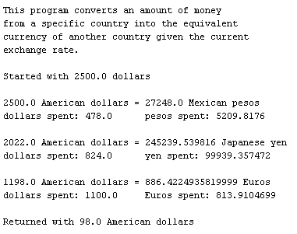

If you chose the second approach, when the program runs correctly, your output will resemble the screen shot below depending on current exchange rates.

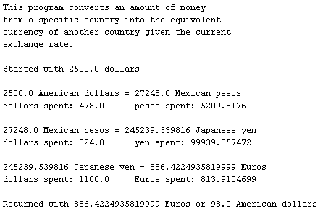

**Note:** There is often more than one way to write a program to solve a problem. It depends on your perspective, and your algorithmic thinking. If you think of an alternative design, please feel free to write it your way.